**flavourSVN:**

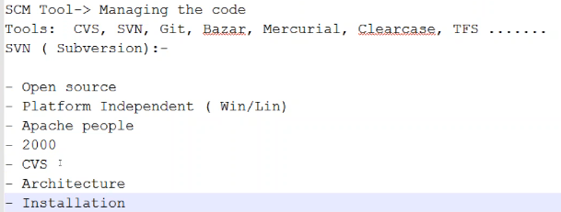

Subversion was created by CollabNet Inc. in 2000 and is now a top-level Apache project being built and used by a global community of contributors.

Subversion is a centralized one unlike the git which is distributed version control

**Architecture:**

* We need to setup SVN server. So that all the developers can store their code in it
* We need to access it through the browser. The browser is called client
* This SVN server doesn’t have the capability of exposing to the external world. So, we need a web server for that
* First, we need to install SVN, then apache web server and we need to establish the connection between SVN and apache. So that the clients can access SVN

**Installation:**

* Copy the link of SVN from bitnami site and download it with wget command
* Then after we need to excute the .run file to install the software. Once the installation is done, then we can access as below
* <https://IP:8080/subversion>

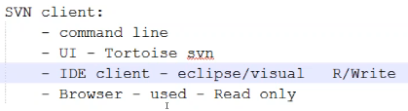

* Through browser, we can just view the content but can’t edit

We need SVN client to access the SVN. There are some types of clients available for SVN

* Command line
* UI
* IDE
* And browser client (The URL which we used to access the client is called browser client. It is just read only)

Remaining all three are read/write clients

* Tortoise SVN is UI and eclipse/ visual studio can be used for IDE  
  download subversion for windows and install it
* Once we install it, to confirm type **svn --version** from windows command line

If we are getting the svn version, then our SVN command line is successfully installed

**Other way to install:**

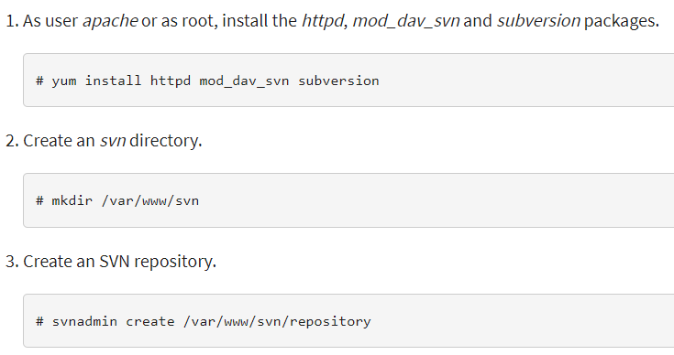

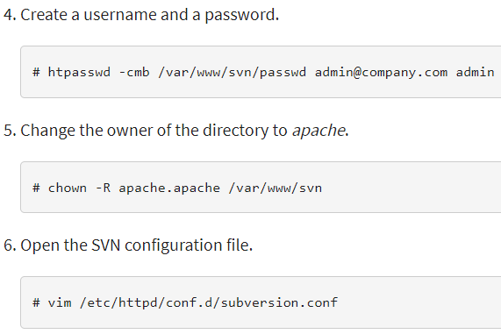

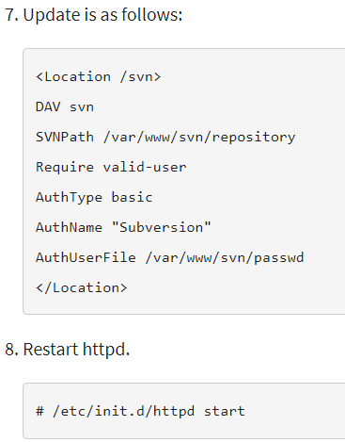

**Installing svn and httpd separately:**

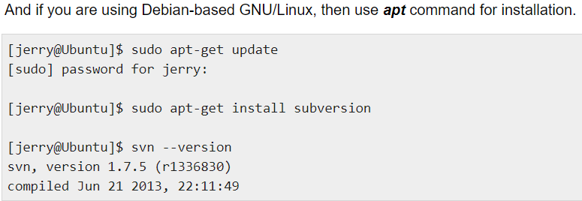

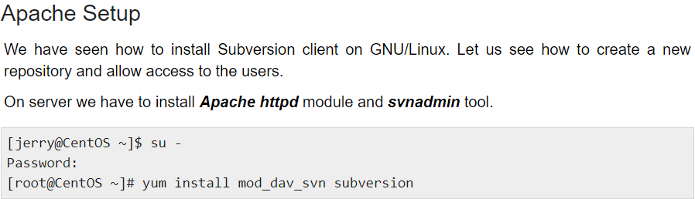

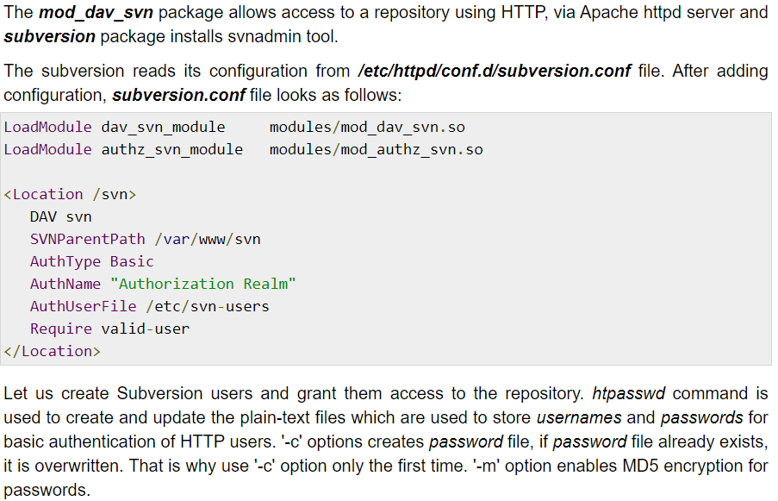

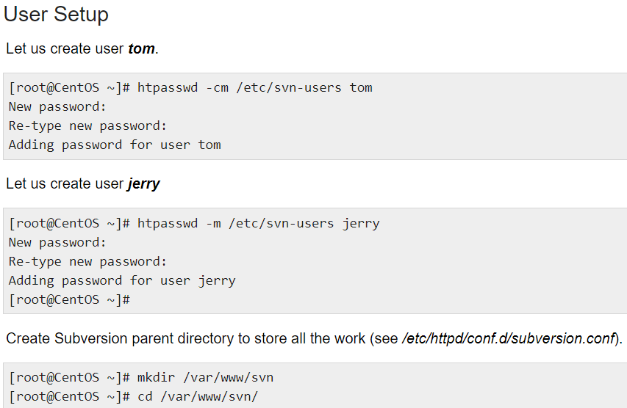

**Subversion Edge:**

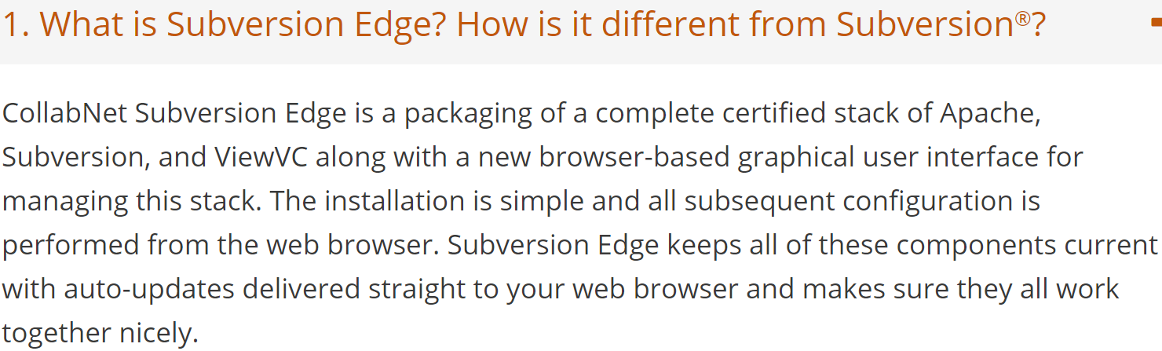

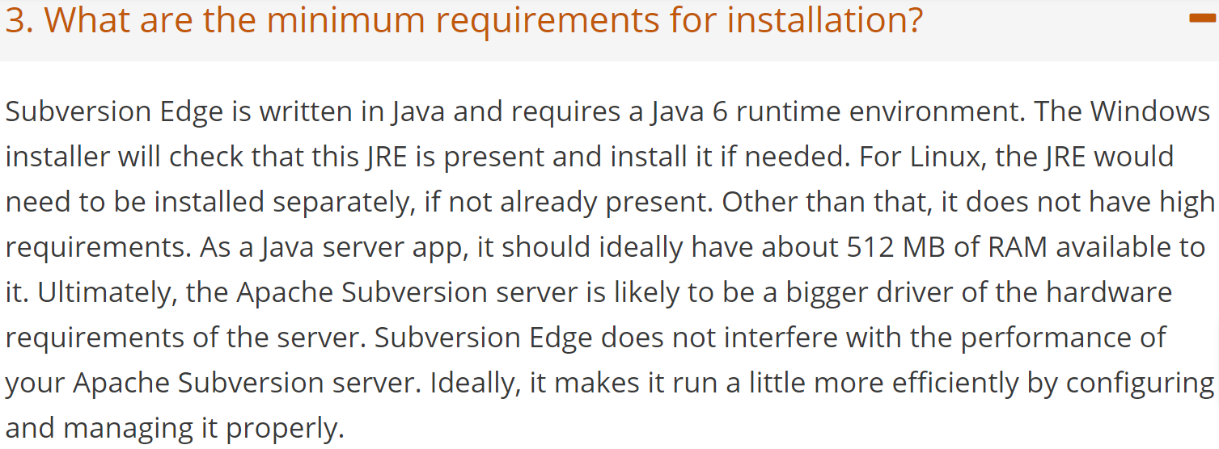

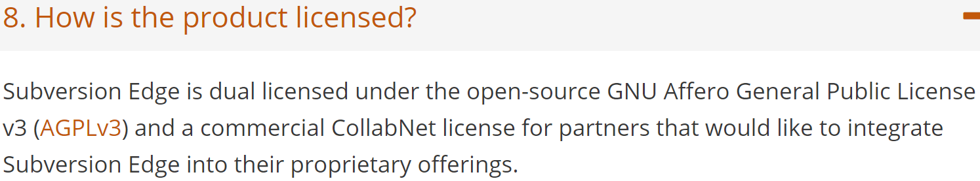

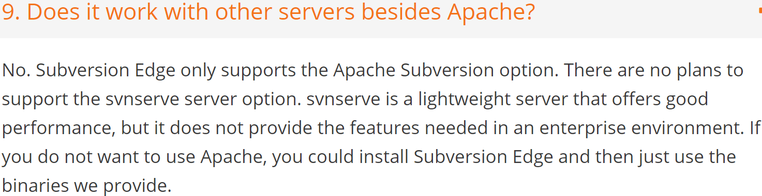

**Installation:**

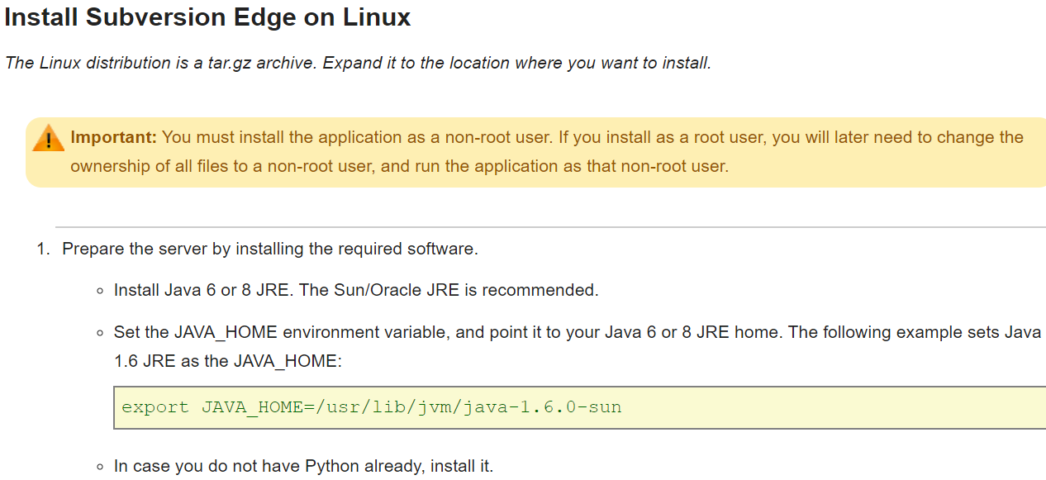

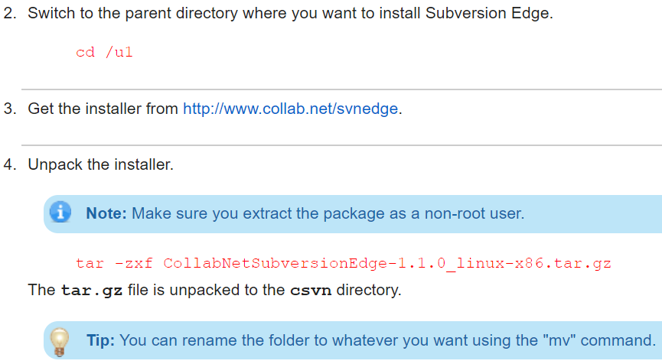

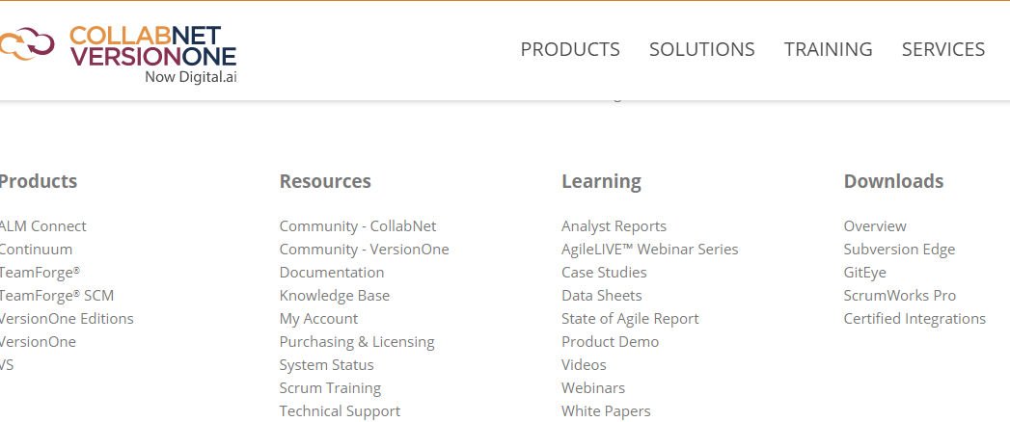

* We need to select whichever subversion we want to download.

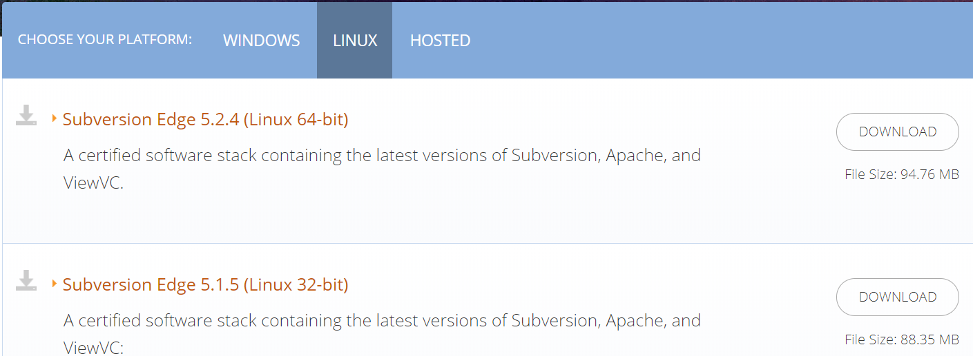

* After this, we need to add our details as below to download the subversion

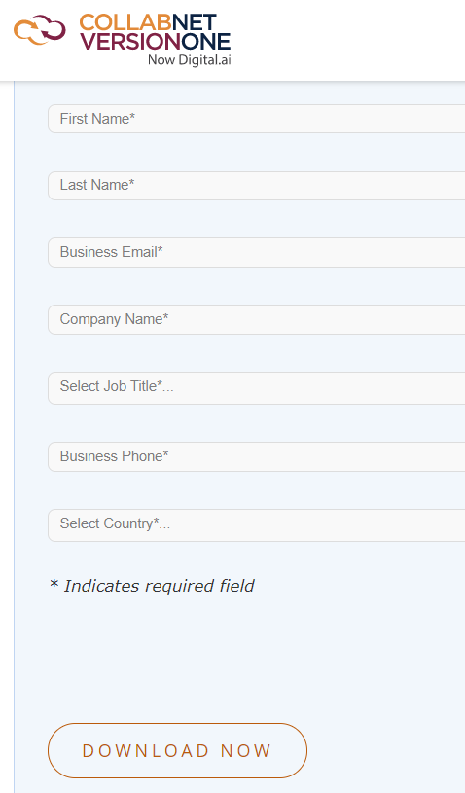

* Once we give the details, a downloadable link will be sent to the email address as below.
* We can download the tar file using the link below from the mail.

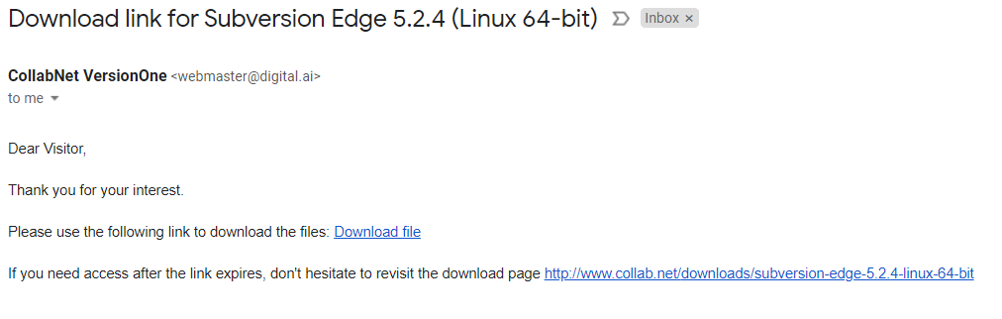

* Once this is downloaded. We can copy the tar file to the Linux server and extract the file

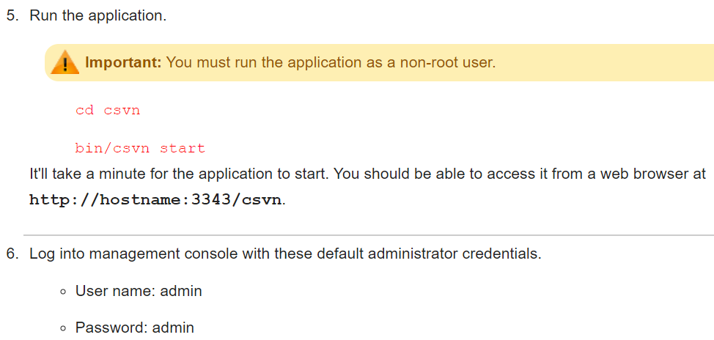

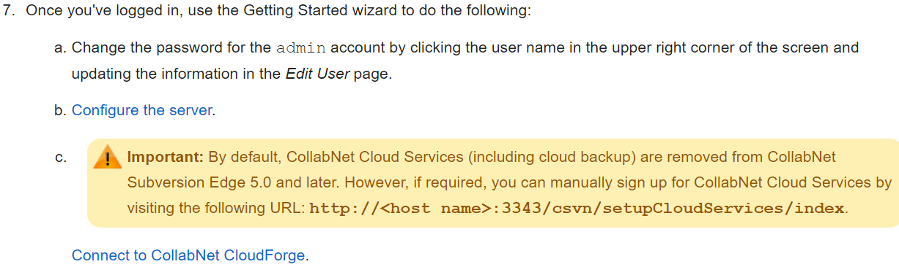

* Once this is done. We can check the curl response from the server itself as below.

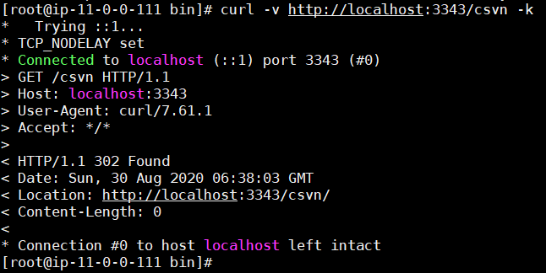

* We need to enable the inbound rule for 3343 port to access the svn from browser.
* Once we login with default user, it is recommended that we need to change the password as below.

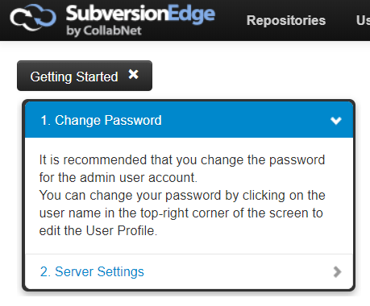

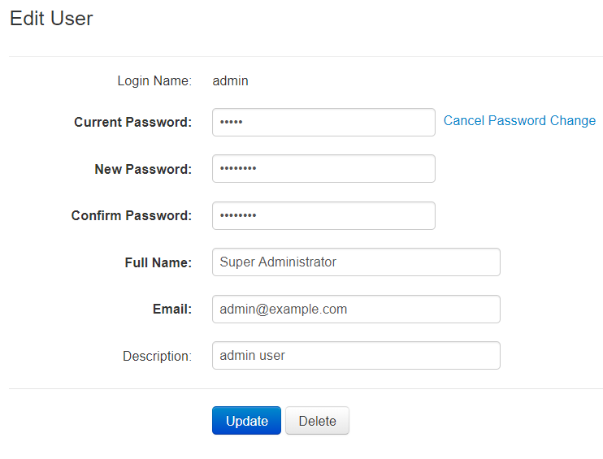

* we also need to start the SVN from browser as below.
* We might get the below error if we start the SVN with root user. So, we need to use the csvn from another user.

